BLE Debugging Note

# Project Files

All of the necessary project files are contained in this patch: [File:BLE Bridge.zip](http://processors.wiki.ti.com/index.php/File:BLE_Bridge.zip" \o "File:BLE Bridge.zip)

To apply the patch, open the .zip file and copy the Project folder to *C:\Texas Instruments\BLE-CC254x-1.4.0* choosing to replace all conflicting files.

Once the project is opened with IAR, you can select the appropriate serial protocol to use by selecting the CC254-SPI or CC2541-UART configurations.

**If you are using IAR 8.30**, you will need to modify your .xcl files to remove the \_NR\_OF\_VIRTUAL\_REGISTERS symbol, as described here: [e2e.ti.com/support/low\_power\_rf/f/538/t/303921.aspx](http://e2e.ti.com/support/low_power_rf/f/538/t/303921.aspx" \t "_blank).

# GAP\_DeviceInit

shcho@shcho-PC-DELL /c/Work.git/ble/BLE-CC254x-1.4.0

$ grep -rn --exclude=\*.map --exclude=\*.pb\* --exclude=\*.[rd]51 "GAP\_DeviceInit" ./Projects/

./Projects/ble/HostTestApp/Source/hci\_ext\_app.c:1386: stat = GAP\_DeviceInit( hciExtApp\_TaskID, profileRole, pBuf[1], IRK, SRK, &hciExtSignCounter );

./Projects/ble/Profiles/Roles/**broadcaster**.c:631: VOID GAP\_DeviceInit( gapRole\_TaskID,

./Projects/ble/Profiles/Roles/**central**.c:152: return GAP\_DeviceInit( gapCentralRoleTaskId, GAP\_PROFILE\_CENTRAL,

./Projects/ble/Profiles/Roles/gap.c:81:bStatus\_t GAP\_DeviceInit( uint8 taskID,

./Projects/ble/Profiles/Roles/**observer**.c:117: return GAP\_DeviceInit( gapObserverRoleTaskId, GAP\_PROFILE\_OBSERVER,

./Projects/ble/Profiles/Roles/**peripheral**.c:1194: VOID GAP\_DeviceInit( gapRole\_TaskID,

./Projects/ble/Profiles/Roles/**peripheralBroadcaster**.c:1059: VOID GAP\_DeviceInit( gapRole\_TaskID,

# pTaskEventHandlerFn

85 /\*\*\*\*\*\*\*\*\*\*\*\*\*\*\*\*\*\*\*\*\*\*\*\*\*\*\*\*\*\*\*\*\*\*\*\*\*\*\*\*\*\*\*\*\*\*\*\*\*\*\*\*\*\*\*\*\*\*\*\*\*\*\*\*\*\*\*\*\*

86 \* GLOBAL VARIABLES

87 \*/

88

89 // The order in this table must be identical to the task initialization calls below in osalInitTask.

90 const pTaskEventHandlerFn tasksArr[] =

91 {

92 LL\_ProcessEvent, // task 0

93 Hal\_ProcessEvent, // task 1

94 HCI\_ProcessEvent, // task 2

95 #if defined ( OSAL\_CBTIMER\_NUM\_TASKS )

96 OSAL\_CBTIMER\_PROCESS\_EVENT( osal\_CbTimerProcessEvent ), // task 3

97 #endif

98 L2CAP\_ProcessEvent, // task 4

99 GAP\_ProcessEvent, // task 5

100 GATT\_ProcessEvent, // task 6

101 SM\_ProcessEvent, // task 7

102 GAPRole\_ProcessEvent, // task 8

103 GAPBondMgr\_ProcessEvent, // task 9

104 GATTServApp\_ProcessEvent, // task 10

105 SerialInterface\_ProcessEvent, // task 11

106 BLE\_Bridge\_ProcessEvent // task 12

107 };

108

109 const uint8 tasksCnt = sizeof( tasksArr ) / sizeof( tasksArr[0] );

110 uint16 \*tasksEvents;

111

112 /\*\*\*\*\*\*\*\*\*\*\*\*\*\*\*\*\*\*\*\*\*\*\*\*\*\*\*\*\*\*\*\*\*\*\*\*\*\*\*\*\*\*\*\*\*\*\*\*\*\*\*\*\*\*\*\*\*\*\*\*\*\*\*\*\*\*\*\*\*

113 \* FUNCTIONS

./BLE\_Bridge/Source/OSAL\_BLE\_Bridge.c

78

79 /\*\*\*\*\*\*\*\*\*\*\*\*\*\*\*\*\*\*\*\*\*\*\*\*\*\*\*\*\*\*\*\*\*\*\*\*\*\*\*\*\*\*\*\*\*\*\*\*\*\*\*\*\*\*\*\*\*\*\*\*\*\*\*\*\*\*\*\*\*

80 \* GLOBAL VARIABLES

81 \*/

82

83 // The order in this table must be identical to the task initialization calls below in osalInitTask.

84 const pTaskEventHandlerFn tasksArr[] =

85 {

86 LL\_ProcessEvent,

87 Hal\_ProcessEvent,

88 HCI\_ProcessEvent,

89 #if defined ( OSAL\_CBTIMER\_NUM\_TASKS )

90 OSAL\_CBTIMER\_PROCESS\_EVENT( osal\_CbTimerProcessEvent ),

91 #endif

92 L2CAP\_ProcessEvent,

93 GAP\_ProcessEvent,

94 GATT\_ProcessEvent,

95 SM\_ProcessEvent,

96 GAPRole\_ProcessEvent,

97 GAPBondMgr\_ProcessEvent,

98 GATTServApp\_ProcessEvent,

99 HeartRate\_ProcessEvent

100 };

101

102 const uint8 tasksCnt = sizeof( tasksArr ) / sizeof( tasksArr[0] );

103 uint16 \*tasksEvents;

104

105 /\*\*\*\*\*\*\*\*\*\*\*\*\*\*\*\*\*\*\*\*\*\*\*\*\*\*\*\*\*\*\*\*\*\*\*\*\*\*\*\*\*\*\*\*\*\*\*\*\*\*\*\*\*\*\*\*\*\*\*\*\*\*\*\*\*\*\*\*\*

106 \* FUNCTIONS

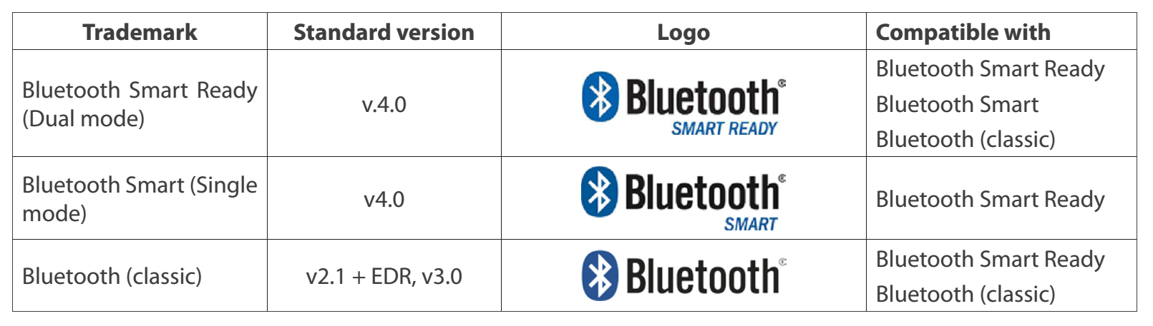./HeartRate/Source/OSAL\_heartrate.c

